***VOTING MANAGEMENT SYSTEM – DATA FLOW DIAGRAM !***

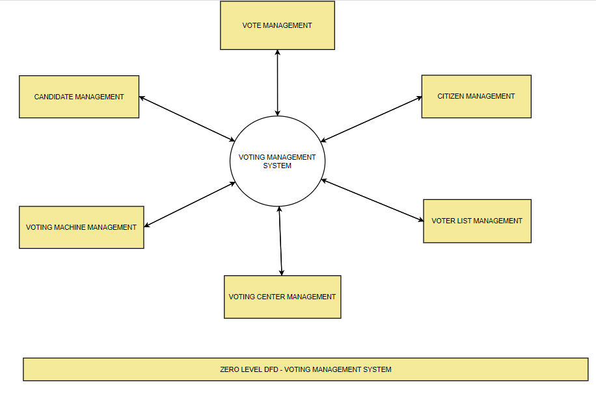

***Problem statements of the project :***

According to Newyork times :

Messing with polling stations is one of the most common voter suppression tactics. Across the country, polling stations have been [closed in minority neighborhoods](https://politics.myajc.com/news/state--regional-govt--politics/voting-precincts-closed-across-georgia-since-election-oversight-lifted/bBkHxptlim0Gp9pKu7dfrN/), had their [locations changed](https://www.nbcnews.com/news/nbcblk/study-north-carolina-polling-site-changes-hurt-blacks-n468251) from election to election, and have been kept [understaffed](https://www.eac.gov/documents/2017/11/15/eavs-deep-dive-poll-workers-and-polling-places/), or [inaccessible](https://www.gao.gov/assets/690/687556.pdf), or [ill-equipped](https://azcapitoltimes.com/news/2018/09/21/county-audit-blames-faulty-equipment-no-back-up-plan-for-election-day-mishaps/), so that voters must stand in line for hours.

These tactics work to lower voter turnout and undermine confidence in the electoral process. In the 2016 election, only [55.4 percent of eligible voters](http://www.cnn.com/2016/11/11/politics/popular-vote-turnout-2016/index.html) actually voted — one of the lowest turnouts in two decades.

Our democracy depends on addressing these vulnerabilities. The more that eligible voters participate in elections and the more transparent and durable the process, the more legitimate the outcome. Fortunately, a simple solution to the problem exists, if we allow citizens to vote online using their smartphone or home computer.

Several advantages of online voting were identified in a [recent post](https://theconversation.com/despite-experts-fears-australia-should-be-moving-to-electronic-online-voting-61832) by Conversation columnist and software researcher David Glance who backed the introduction of such a scheme in Australia.

He is correct that an online voting system would be faster, more convenient and have fewer accidental informal votes. It would also reduce the donkey vote problem (though the “donkey vote” bias can also be dealt with by the use of [Robson rotation](http://www.parliament.tas.gov.au/tpl/backg/HAElections.htm) on printed ballots).

Online voting websites are software platforms that allow you to run secure, digital votes and elections.

The term “online voting website” is a bit of a misnomer. In reality, most online voting websites are web-apps, and commonly referred to as [online voting systems](https://www.eballot.com/votes-and-elections/what-is-an-online-voting-system).

These voting web apps are beneficial because they make it easy for all your voters to securely log into the voting application — without having to download an app. They simply run in your browser.

What’s involved with voting? Your voters will:

* Open a browser
* Log into the voting website app
* Vote

From there, and often times instantly, you'll get the results.

For knowing more : <http://homepage.divms.uiowa.edu/~jones/voting/congress.html>

**It’s Time for Online Voting**

Using blockchain technology, online voting could boost voter participation and help restore the public’s trust in the electoral process and democracy.